**IBM Assignment**

**Temperature and PIR sensors project**

Code for the project:   
  
void setup()

{

Serial.begin(9600);

pinMode(2, INPUT);

pinMode(12, OUTPUT);

}

void loop()

{

int motion=digitalRead(2);

double temperature=analogRead(A2);

double detectedtemp=(((temperature/1024)*5)-0.5)*100;

if(motion==1)

{

tone(12,400);

delay(1000);

noTone(12);

delay(1000);

}

if(detectedtemp>60.00)

{

tone(12,300);

delay(1000);

noTone(12);

delay(1000);

}

}

Circuit Diagram:   
  
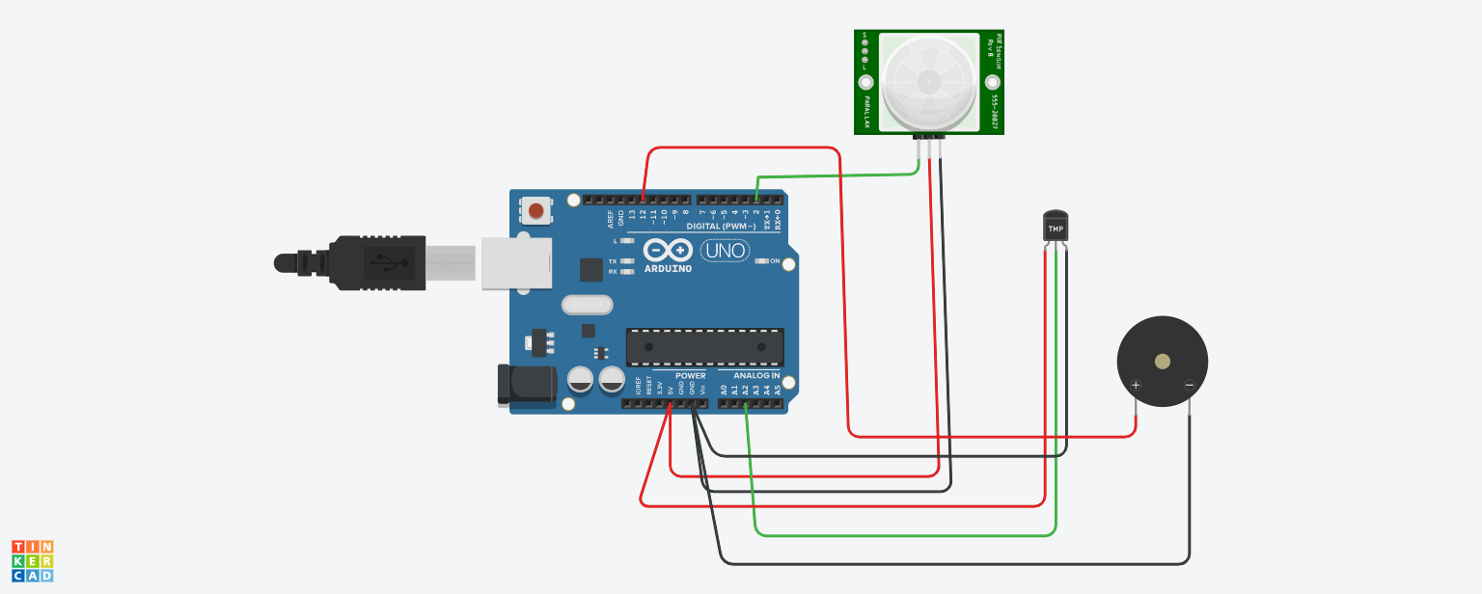

Demo Link:   
  
You can follow this link to tinker the mentioned project

[IBM Assignment - Temperature and PIR Sensor Project](https://www.tinkercad.com/things/6JYWYptqIsY?sharecode=IPwBShWYZTTDAjiW3u-qDW5bzebwqtXcEUz7Lufn6xM)